**Policy Brief, May 2025, Maseru, Lesotho**

**Implementing the African Union Transitional Justice Policy in Lesotho: Pathways to sustainable peace, justice and reconciliation**

By

Khabele Matlosa[1] & Moeketsi Kali[2]

1. **Key Messages**
   1. The 2019 African Union Transitional Justice Policy (AUTJP) is not well known in Lesotho, despite the country being one of the 55 Member States of the African Union (AU).
   2. Based on the AUTJP, in conformity with the 2022 decision of SADC Summit and in the context of the on-going comprehensive governance reforms, Lesotho has to institutionalise sturdy national infrastructures for peace and a robust transitional justice (TJ) architecture.
   3. To this end, Lesotho has to develop a national TJ policy aligned with the AUTJP.

1. **Introduction**

Lesotho society is marked by an entrenched culture of violence whose roots are traceable to authoritarian governance of both civilian (1970-1986) and military (1986-1992) varieties. Authoritarian rule inflicted massive human rights violations whose scars still remain visible on the country’s social fabric despite the transition to multi-party and constitutional democracy in 1993. The current democratic governance dispensation (1993-2025) has not redressed the challenge of an embedded culture of violence and protracted conflicts wherein human rights are trampled underfoot (Kapa, 2017; Matlosa, 2020; Kali, 2022).

Given that Lesotho is one of the 55 member states of the African Union (AU), it has to draw from the 2019 Africa Union Transitional Justice Policy to put in place strong national infrastructures for peace (I4Ps) and a robust TJ architecture (Matlosa, 2024). The analysis in this policy brief draws from desk research, empirical research and public consultations undertaken by the Lesotho Council of Non-Governmental Organisations (LCN) and Strategic Institute for Research and Dialogue (SIRD) between November 2024 and March 2025 supported by the Africa Transitional Justice Legacy Fund (ATJLF) with financial supported from the European Union (EU) and African Union (AU). This project entailed community consultations across all the 10 districts[3] of Lesotho and administration of a questionnaire to a 43 purposively selected experts[4].

1. **Critique of the policy environment**

TJ is often a propitious policy response in countries engulfed in pervasive violent conflicts, either transitioning from autocracy to democracy and/or from war to peace. Post-colonial Lesotho has been entangled in protracted violent conflicts. Although contemporary Lesotho has been spared the vagaries of a full-blown and outright war, it has been historically bedeviled by an embedded culture of violence as illustrated in Table 1.

**Table 1: Historical Trajectory of the Culture of Violence in Lesotho**

|  |  |  |  |
| --- | --- | --- | --- |
| **Period** | **Governance Type** | **Regime Type** | **Magnitude of Violence & Human Rights Violations** |
| 1966-1970 | Embryonic Multiparty | Democratic | Covert & Sporadic |
| 1971-1985 | One party | Authoritarian | Overt and Generalised |
| 1986-1992 | Military | Authoritarian | Overt and Generalised |
| 1993-2001 | Dominant party | Democratic | Covert and Sporadic |
| 2002-2011 | Dominant party | Democratic | Covert and Sporadic |
| 2012-Todate | Coalition | Democratic | Covert and Sporadic |

**Source**: Authors’ Own Compilation

Since 1966 to date, post-independence Lesotho has been marked by violent conflicts of various types and magnitudes. Following a brief period of an embryonic democracy, the country’s political system has evolved from a one-party and to military autocracy and back to multi-party democracy of a dominant-party type and ultimately a coalition governance type.

1. **Research Overview**

Lesotho is embarking on a comprehensive national reform process aimed, in the main, at addressing the all-pervasive violent conflicts, instability and insecurity. The immediate trigger for the reforms was the 2014-2015 political crisis[5] which led to the Southern African Development Community (SADC) deploying the SADC Observer Mission in Lesotho (SOMILE) between September 2014 and November 2017. In its final report, SOMILE recommended, among others, comprehensive governance reforms for Lesotho (Pherudi, 2023). In its 2017 framing document, the Government made a firm commitment to “undertake far-reaching reforms to ensure stability and prosperity. Basotho deserve to live in a stable, peaceful and secure environment and be assured of the enjoyment of their rights and efficient service delivery” (Government of Lesotho, 2017:4).

Since 2019, Lesotho has been embarking on a tortuous journey of comprehensive governance reforms covering seven thematic areas as follows: Constitution, Parliament, Security Sector, Justice Sector, Public Service, Economy, and Media. The MSND plenary II report details the form and substance as well as the execution of these envisaged reforms (Government of Lesotho, 2019a:47). Additionally, peacebuilding is part and parcel of this reform agenda, specifically the institutionalization of transitional and other justice processes. The National Reforms Authority (NRA) was established in 2019 through an Act of Parliament to coordinate the implementation of these seven-pronged reform agenda. Significantly, the NRA was also tasked with the mandate of putting in place peacebuilding and transitional justice mechanisms aimed at conflict prevention, management and resolution needed for durable stability of the country (Government of Lesotho, 2019b).

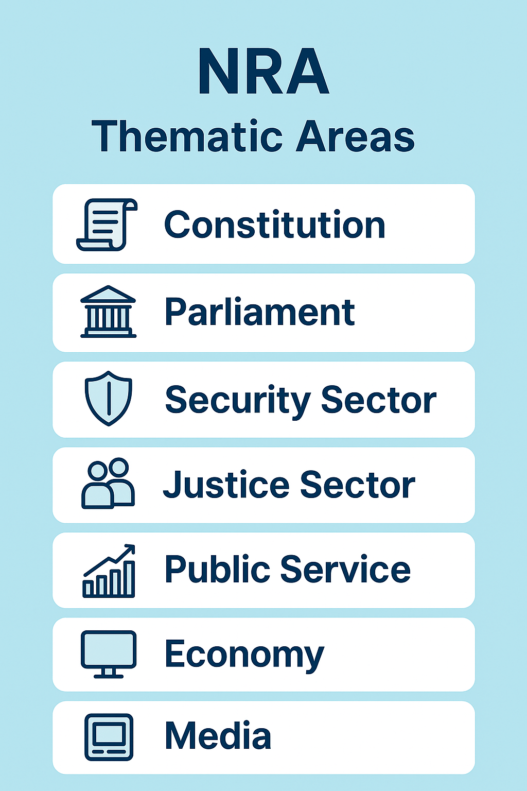

The NRA organized a national multi-stakeholder consultative forum held at Manthabiseng Convention Centre in Maseru on 21-23 July 2021, supported by the government, the EU, AU, SADC and UNDP. The forum was convened under an appropriate theme: ‘The Path Towards Sustainable Peace, National Unity and Reconciliation: The Lesotho We Want’. This forum contributed immensely in galvanizing public opinion, providing victims and survivors of violence and human rights violations an opportunity to express their opinions and ensuring broad-based participation towards crafting an appropriate I4Ps framework and the TJ architecture for Lesotho.

Following plenary and panel discussions as well as breakout sessions, the 2021 national forum advanced several recommendations aimed at institutionalizing peacebuilding, reconciliation and transitional justice include. These include the following:

* The need to establish an inclusive national peace architecture decentralized to all the ten districts of the country;

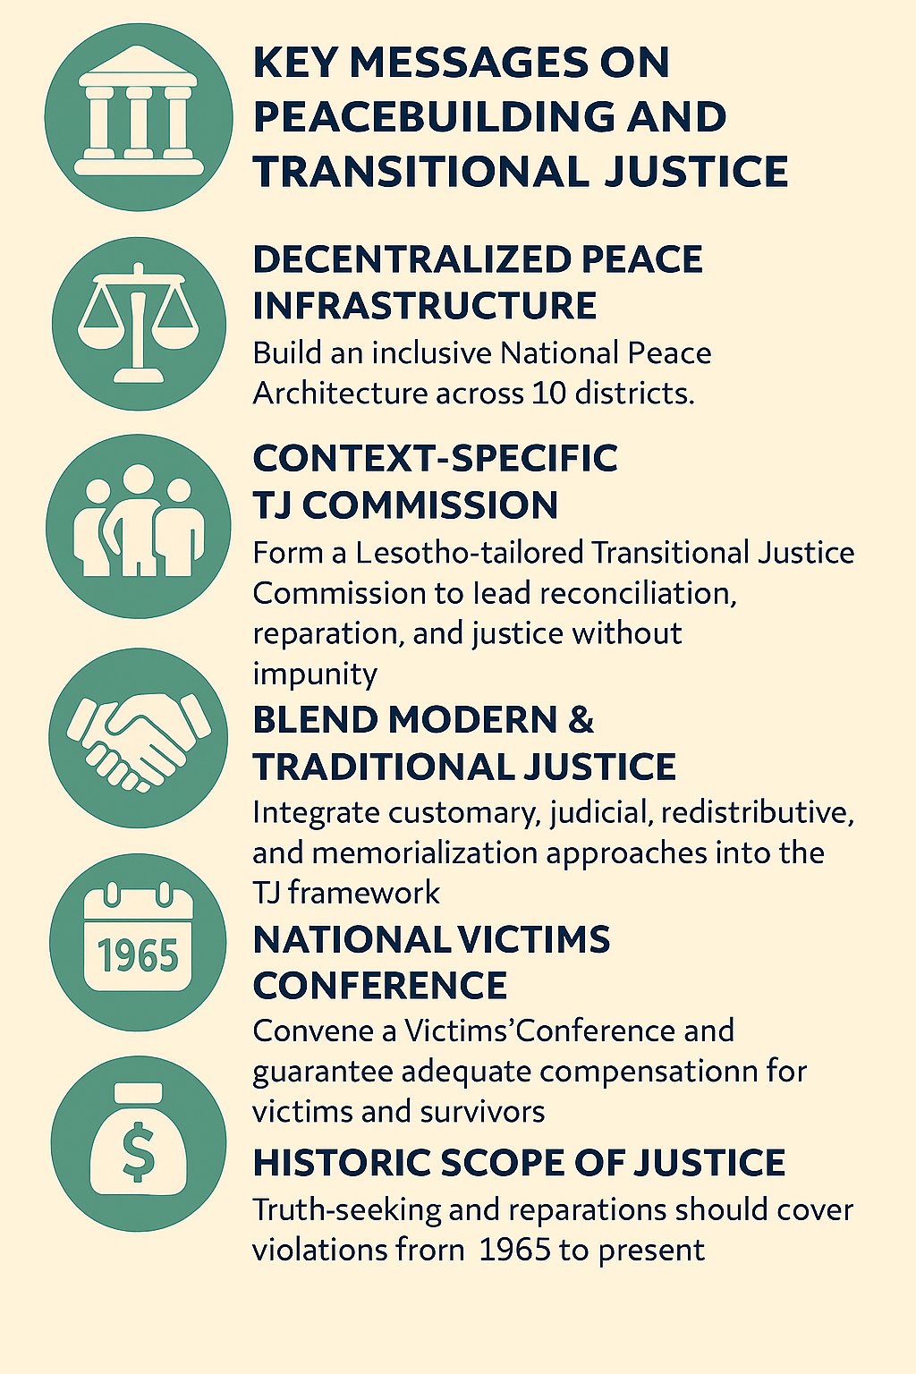

* The need to establish an all-encompassing transitional justice commission suitable to the Lesotho context to drive reconciliation, peacebuilding, reparation, and compensation without compromising justice and without promoting impunity;
* Lesotho’s transitional justice architecture should incorporate existing traditional justice and peacebuilding structures, redistributive approaches, memorialization approaches and judicial approaches;
* Broad-based consultations with victims and survivors of human rights violations and other key stakeholders should form the basis of the legal framework for the transitional justice mechanism to ensure that truth is known, justice is served, victims get reparation and amnesty is recommended where it is due;
* The need to convene a Victims Conference and that victims and survivors should be adequately compensated for their suffering;
* Consensus emerged among participants that the time-frame for truth-seeking, reparations, compensation, and accountability should be 1965-to date; and
* Reparations should include offering employment to victims or their off-spring, financial compensation, returning land to those who are dispossessed of their land; offering counselling and training, providing compensation to the Lesotho Liberation Army (LLA) (NRA, 2021).

At the time of this consultative forum, the government had tabled a bill before the National Assembly styled the National Peace and Unity Bill, 2021. This Bill had triggered enormous controversy among various stakeholders. Essentially, the Bill had four main shortcomings. Firstly, it was perceived to lack broad-based participation of key stakeholders especially the victims and survivors, as it was not preceded by multi-stakeholder consultations. Second, it was perceived to be aimed at exonerating perpetrators of human rights violations, especially those wielding executive power, at the expense of victims and survivors. Third, the government of the day had submitted the Bill directly to the National Assembly by-passing the NRA despite the 2019 NRA Act specifying this task as one of the latter’s functions. Fourth, and finally, the form and substance of the Bill was largely not in full compliance with the full range of core principles of the 2019 AUTJP. Subsequently, this Bill never saw the light of day and was not promulgated into law.

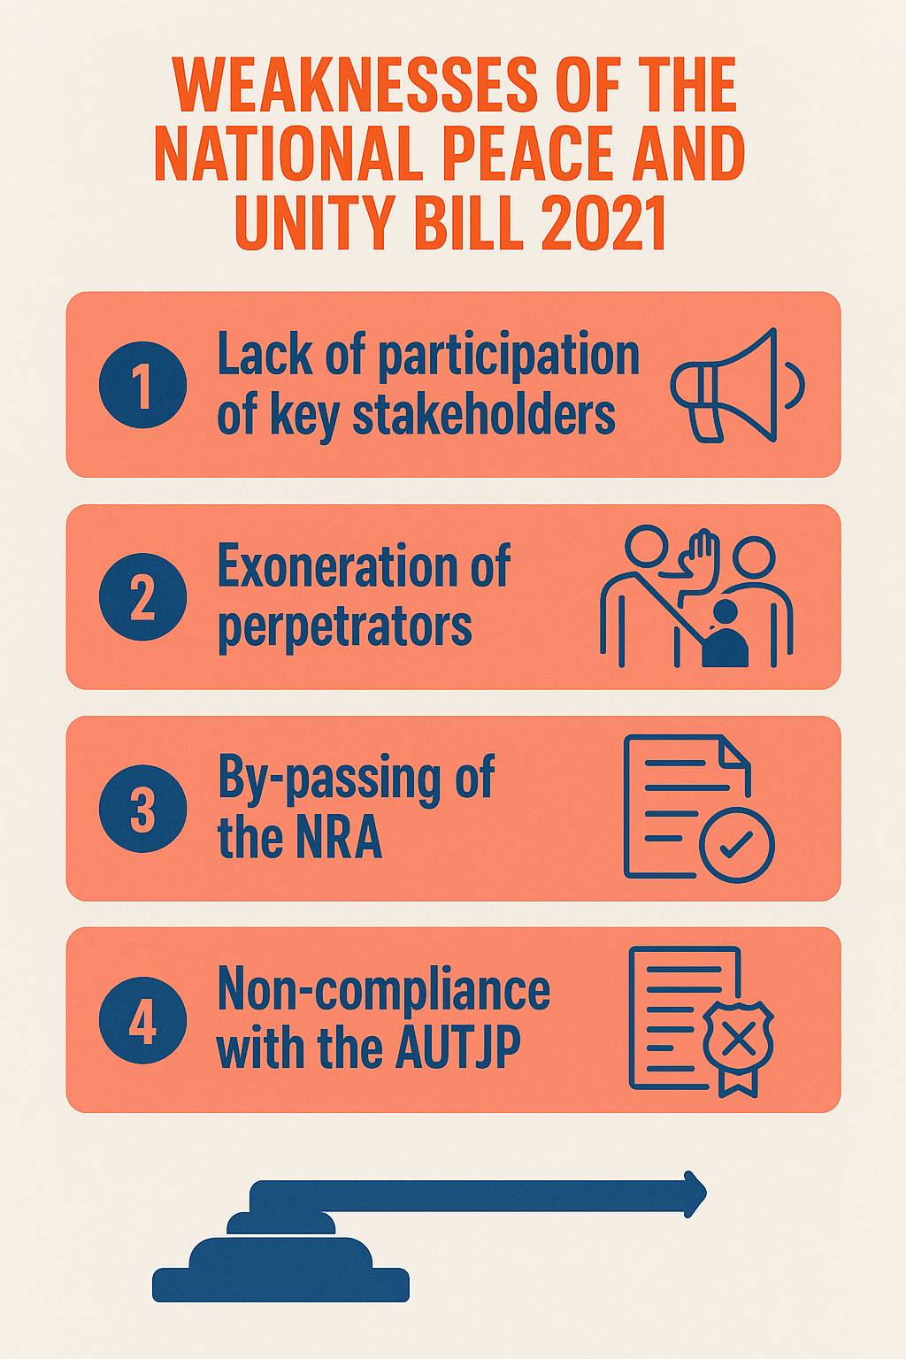

1. **Implications and Policy Recommendations**

This policy brief makes a case for various stakeholders to make deliberate efforts to uproot the culture of violence in Lesotho. It shows that violent conflicts and instability in the country undermine socio-economic development, sustainable peace and democratic governance. They also lead to human and peoples’ rights violations, with the hardest-hit social groups being women and girls, children and youth, as well as persons with disabilities and older persons.

Six policy recommendations are in order. First, state and non-state actors must develop a national TJ policy, aligned with the AUTJP, and ensuring the participation and representation of victims/survivors. Second, Parliament must promulgate of national TJ legislation. Third, government must establish the requisite peacebuilding and TJ mechanisms. Fourth, resources must be mobilised for these mechanisms so that they are operationalised. Fifth, to function effectively and efficiently, the mechanisms must be insulated from political interference and undue influence. Finally, it is essential that victims/survivors are organised into a network or association so that they contribute meaningfully to all TJ processes. But for this to happen the culture of impunity and fear in the country has to be eradicated.

**Acknowledgements**

We sincerely extend our appreciation to the three Research Assistants at the Strategic Institute for Research and Dialogue (SIRD)—Mrs. Sophy Sutha, Ms. Motena Khuto, and Ms. Mats’ele Sesoane—for their dedicated support during the public consultations and for their invaluable assistance during the process of data collection, collation and transcription of the rich conversations during in-district public consultations.

**References**

Government of Lesotho .2017. The Lesotho We Want: Dialogue and Reform for National Transformation, Maseru, Lesotho.

Government of Lesotho. (2019a) Multi-Stakeholder National Dialogue, Plenary II Report, Manthabiseng Convention Centre, Maseru, Lesotho, 25-27 November.

Government of Lesotho. (2019b) National Reforms Authority Act, Vol. 64, No. 62, 8 November.

Kali, M. (2022). ‘The untold story of civil society organisations’ contribution to peacebuilding in Lesotho’, *International Politics*, 59, pp1082-1100, <https://doi.org/10.10571s4131-021-00345-w>.

Kapa, M. (2017). ‘Roles of Civil Society in Conflict Situations in Sub-Sahan Africa: The Case of Lesotho’, in Berhanu, K. and Chimanikire, D. (eds). *The Roles of Civil Society in Conflict Management and Peace Building in Eastern and Southern Africa*, Addis Ababa, Organisation for Social Research in Eastern and Southern Africa, pp259-288;

Matlosa, K. (2020). ‘Pondering the culture of violence in Lesotho: a case for demilitarization’, *Journal of Contemporary African Studies*, 38(3), pp381-398.

Matlosa, K. (2024). ‘African Union Transitional Justice Policy Implementation Guidance: Lesotho’, Policy Paper Centre for the Study of Violence and Reconciliation (CSVR), Johannesburg, South Africa, 24 December.

Pherudi, M. (2023). *Lesotho on SADC Agenda: Challenges of Instability and Prospects for Peace*, Pretoria, UNISA Press.

National Reforms Authority. (2021) The Path Towards Sustainable Peace, National Unity and Reconciliation: The Lesotho We Want, Report of the National Stakeholder Consultative Forum held on 21-23 July 2021 at Manthabiseng Convention Centre, Maseru, Lesotho.

1. Khabele Matlosa is the Executive Director at SIRD, Research Fellow, Africa Institute of South Africa at the Human Sciences Research Council, Pretoria South Africa and the Visiting Professor at the Centre for African Diplomacy and Leadership, University of Johannesburg, South Africa. His contact details are as follows: Tel/WhatsApp: +26657984471 and email: [matlosak@gmail.com](mailto:matlosak@gmail.com) and [khabelematlosa@rocketmail.com](mailto:khabelematlosa@rocketmail.com).
2. Moeketsi Kali (PhD) is the Program Manager, Strategic Institute for Research and Dialogue (SIRD) and a Political Science Lecturer at the National University of Lesotho (NUL). His email is: [kalimoeketsi2@gmail.com](mailto:kalimoeketsi2@gmail.com)
3. The data underpinning this brief emanates from extensive consultations by Lesotho Council of NGOs (LCN) and the Strategic Institute for Research and Dialogue (SIRD) held across all ten districts of Lesotho between 16 January to 6 February 2025 with 873 participants. A total of 873 participants were engaged across Lesotho, with the highest numbers in Mohale’s Hoek (163), Quthing (143), and Qacha’s Nek (113), and lower turnouts in districts like Mokhotlong (38) and Mafeteng (43).
4. The 43 key informnts were drawn from various sectors including government, civil society, faith-based organisations, traditional/local authorities, academia, diaspora, women, media, youth, persons with disability, multilateral intergovernmental organisations, and international non-governmental organisations.
5. It was during this period that Lesotho experienced a multiplicity of overt violent conflicts including an abortive military coup, armed conflicts between the military and the police, the bombing of residences of the police commissioner, torture of some soldiers and fleeing of others into exile in South Africa, the assassination of the army commander, Lt-Gen. Maaparankoe Mahao prompting SADC to institute a Commission of Inquiry-the Phumaphi Commission. Two years later, the instability within the Lesotho Defence Force led to the assassination of another commander, Lt-Gen. Khoantle Motsomotso.